Bodmin angling association newsletter
2025
Secretaries Report

As we come to the end of another successful fishing season, we would like to start by thanking everyone who took part in the work parties.
This is what this year's work parties achieved; In April we cleared the access to most of the paths. These beats were carefully chosen by B.A.A. Head warden Ollie Rowe.
In June through to mid-August the Camel Fisheries Association and Bodmin Angling Association started gravel cleaning on a new stretch of the river Camel just above Hendra bridge. This was extremely tough going to start with due to nothing being done there for several decades and the amount of thick growth from the Hemlock and other foliage but by using the IBC rafts it did make things a bit easier when taking materials away from the site. The total length of river this year that has been cleaned to improve the gravels for fish to spawn in is about three kilometres
In June the Bodmin Anglers Committee decided to open the Denby beat for the Club's members to fish. We also worked on a small project with Angling Trust the pulling of Himalayan Balsam, a couple of large areas were cleared in Denby which allows things like grass to grow back.
What a season it's been! This season has been noticeably better and many of the club members that I have spoken to believe the improvement is largely due to the gravel cleaning that has been carried out in the previous years.
There were sightings of big Salmon and Sea Trout in the river before the fishing season had started. When the fishing started there were some good size Salmon and Sea Trout hooked and lost and landed even though it was quite a dry summer fish continued to enter the river many of the regular anglers changed their methods and tackle to suit the river conditions which increased their catch. One club member reported catching and releasing sixteen Seatrout in three short visits to the river. The river did rise quite high on several occasions during the last couple months of the fishing season and there was some nice Salmon caught and returned one club member caught and returned two Salmon in two short visits.

Tight Lines John Rossiter B.A.A Secretary.

Work party dates
Organised by Ollie Rowe head warden
Sunday 11th of April 2026 is at Shell Woods meet at 9-30
Sunday 19th of April 2026 is at Boscarne meet at the Bourough Arms Car Park at 9-30
Sunday 26th of April 2026 is at Dunmere Meadow’s meet at the Bourough Arms Car Park at 9-30
Work gloves and hand tools only please

This years gravel cleaning muddy ditch full of weed
To clean spawning gravel that has already got redd’s in
Well done the gravel cleaners
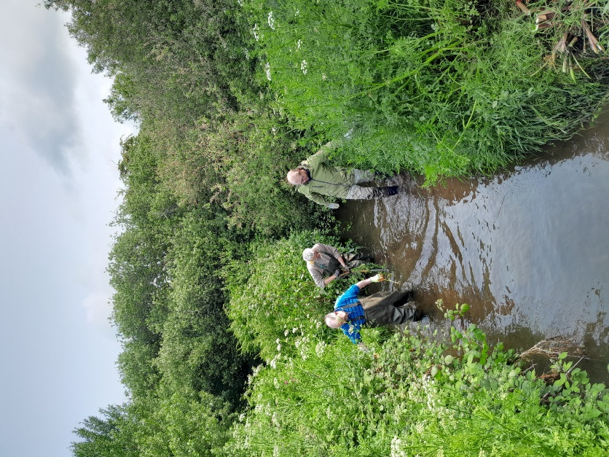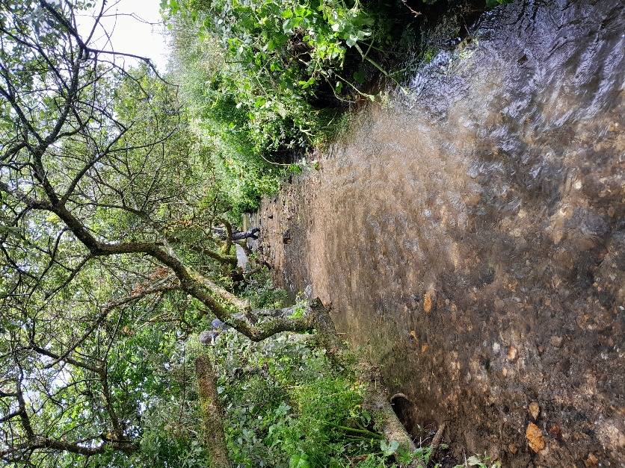

Minutes of Bodmin Anglers Association AGM, 2025

Slade’s House Country Inn, Sladesbridge, Egloshayle, Wadebridge. PL27 6JB

7:30 p.m. 21/2/2025

- Apologies

Apologies were received on behalf of:
Mr. P. Hutton, Mr. A. Comber, Mr. D. Evans. Mr. D. Osborne, Mr. G. Semmens, Mr. P. Rowland, Mr. A. Dale, Mr. R. White, Mr. J. Ford-Dunn, Mr. M. Croghan, Mr. R. Iddison, Mr. S. Pearce.

- Minutes of the last AGM (held on 16/2/24)

Minutes of the 2024 AGM were available on the club website and also circulated by email with the Christmas newsletter. They were proposed as an accurate record by Mark King and seconded by Nick Solomon.

- Correspondence

No correspondence had been received with regard to the AGM.

- Matters arising

There were no matters arising.

- Election of President, Countess. Dianne (Pinky) Le Grelle

The motion was proposed by Ollie Rowe, seconded by Steve Meeks and carried unanimously.

- Election of Vice-President Mr. Ivan Lyne

The motion was proposed by Ollie Rowe, seconded by Paul Wallace and carried unanimously.

- Election of Officers and Committee (on block)

The Secretary (John Rossiter) listed the officers and their roles: Stuart Fullwood (Chairman), Graham Toms (Treasurer and Membership Secretary), Chris Janes (Vice-Chairman), Mike Smith (Assistant Secretary), Ollie Rowe (Head Warden), Pete Jago (Catch Returns Officer), Aaron Meade (Website Manager).

As all the above had agreed to continue serving and no other nominations had been received the Chairman suggested that the officers could be elected on block. This was proposed by Mark King, seconded by Paul Wallace and carried unanimously.

- Appointment of Auditors (K. Chapman)

This motion, retaining the existing auditors, was proposed by Pete Jago, seconded by Marc Knight and carried unanimously.

- Guest Speaker

Unfortunately a guest speaker from Angling Trust was not able to attend, but Marc Knight (Camel Fisheries Association, Secretary) stepped in and gave a short talk on the gravel restoration work carried out last summer. He had a photograph album of before and after pictures of the stream which was available for attendees to inspect. He noted the large amount of hemlock that had been removed and the subsequent improvement of the quality of the stream bed gravels. He also noted that the gravels had continued to improve with winter spates and that on a recent visit to the site there did appear to be some clean patches of gravel that were potentially redds. The land owners were pleased with the work as were Natural England and the EA. Marc was just starting the process of obtaining consents to carry out similar work this year on the section of river upstream of the bridge at Hendra. Marc also stressed that more volunteers were required to help with this work, rather than relying on a small group of stalwarts. A vote of thanks to all those who had helped with the work was proposed and well received.

- Chairman's Update

Stuart Fullwood advised that there were a lot of things going on with Natural England (NE) and the Environment Agency (EA), where progress was slow but the processes were on-going. He had been in touch with the EA regarding the gauging station removal works at Denby, but was currently awaiting a reply from them. He added that it was hoped that we would be in a position to reopen this beat this year.

Plan to remove the weir at Dunmere

Stuart noted that he had recently sent an email to EA, NE and West Country Rivers Trust (WRT) objecting strongly to the plan to remove the weir at Dunmere. This not only pointed out the fact that the weir dos not pose a significant barrier to salmonid migration, but also highlighted potential negative impacts on a number of other species with important conservation status. The included bullheads, lampreys and bats. In addition to the direct loss of bat feeding habitat, bat conservation might provide grounds for preventing the felling of any oak trees in order to access the site and Stuart had asked for environmental impact assessments with regard to these species. It was thought that 5 years of surveys carried out during summer months were required to comply with EU conservation directives for bats. In response to a request for contact details of potential bat experts, Cornwall Wildlife Trust was suggested as they carry out bat surveys and Stuart responded that he would follow this up. The timing of the work During July and August was likely to be damaging to migrating salmonids and also possibly other species such as lamprey which would be spawning in summer.

It was thought that the silt deposits in the Dunmere Pool might be important habitat for juvenile lampreys and it was noted that spawning lampreys had been seen at Tresarrett and that video of them might be available on U-tube.

There was a question from the floor asking why the weir at Dunmere was to be removed. Stuart replied that the removal of potential barriers to salmonid migration was topical worldwide at the moment and WRT had funding for projects of this nature.

John Rossiter noted that access for heavy plant required for the weir removal could be an issue, with the bridge to the meadows too weak to allow access. Ctss. Le Grelle said she would refuse access through Parkwood on her land. Another potential way in was through Pencarrow Estate.

Steve Meeks advised that he had written to local MP Ben McGuire and asked him to raise the issue with the Environment Minister. He thought there was a need to raise publicity about the issue. Paul Wallace suggested contacting Angling Trust (AT) and John Rossiter replied that he had recently discussed this with the AT representative for the southwest.

Discussion continued including comments that the weir at Kenningstock is a more serious obstruction, that the WRT low water assessments had been carried out during an exceptionally dry year and when the leat sluice was damaged resulting in unusually low flows in the main river, that the Dunmere weir slows the flow of the Camel in spate conditions and that removal would release substantial amounts of silt downstream. It was also commented that no planning applications had been seen and that the process seemed to have circumvented these.

There was a comment from the floor asking whether it was possible to get the weir listed. Stuart Fullwood also noted that protection of listed buildings at floodrisk downstream might provide grounds for objection but that he was only aware of 1 such building (John Evan's), well downstream.

- Secretary's Update

John Rossiter commented that fish numbers in recent years had been reasonably good, especially for sea trout and that there was some good fishing last year. He also reminded members that the EA bye-law had been renewed for another 5 years and that members should check the regulations regarding hook specifications.

- Treasurer's Update

Graham Toms advised that the club was financially stable having obtained income of £7900 last year with rents currently running at £7000 p.a. Allowing for other expenses the club was around break-even or in slight surplus. Full accounts were available to view on request. He also noted that the formal accounts sometimes show an in-year loss due to rents being paid before subscriptions are received. The club also had significant reserves in the bank. There was no need at present to increase subscriptions.

- AOB

Paul Wallace asked about the situation at Grogley (Denby). Stuart Fullwood advised that their had been long delays in getting replies and progress from the EA. Recently Pete Jago had been in touch with a contact he knew at EA and who had been in charge of the Denby gauging station removal project. Pete advised that his contact had requested a completion certificate for the work and lease documents and would provide these when available. This should provide the documentation the club needs to move forward with this issue and it is hoped the club will be able to reopen the beat this year. It was also commented that the course of the river and potential future erosion was not the responsibility or liability of the club.

Steve Meeks (Wadebridge Anglers Association, Committee member) acknowledged that he had not put forward a motion in writing in advance of the meeting, but nonetheless asked that he be allowed to speak. He felt that EA did not engage constructively and effectively with WAA, BAA or CFA and that amalgamating BAA and WAA might provide a stronger voice and a more coordinated approach. He also noted that both clubs had experienced reduced membership in recent years and also lacked younger members and he thought that a larger amalgamated club might be in a better position to address these problems and help sustain fishing on the river Camel. He suggested that a sub-committee be set up to consider this and report at next years AGM. This suggestion was subsequently proposed by George Bristow, seconded by Chris Rowland with a show of hands indicating around 50% in favour.

- Raffle and Auction

Fishing tackle and other items had been donated to raise funds for the club. Smaller items were allocated as raffle prizes while the more expensive items put up for auction. Ollie Rowe and Lisa Rossiter had sold raffle tickets before the meeting and Ollie proceeded to carry out the raffle draw and then the auction. Initial estimates suggested around £400 was raised for club funds and Ollie and Lisa were thanked for their efforts and given a round of applause.
Tight lines for 2026
Regards the team.

